- Name of Use Case
Name of the Use Case | IoT platform for patient health monitoring
Version No. | v0.1
Submission Date | 10/12/2021
Team Members (with student ids) | Sara Siragusa (292162), Silvia Polizzi (292179), Annalisa Perioli (285863), Iman Ostovar (272561)
- Scope and Objectives of Function
Scope and Objectives of Use Case
Scope | The proposed IoT platform aims at providing services for patient home monitoring and hospital monitoring.
Objective(s) | The expected results aims at providing a monitoring of the vital parameters of a homebound patient in order to check the state of health. The use of this IoT platform helps to avoid the Hospital overcrowding, exposing the patient to the risk of contracting infectious diseases, making fragile patient move without necessity.
Domain(s) | Health, Hospital utilities
Stakeholder(s) | Patients, Doctors, Hospitals, Caregivers
Short description | The proposed IoT platform aims at offering an additional resource to telemedicine. It integrates different IoT devices for managing vital parameters (i.e. temperature, SpO₂ level, heart rate). It provides control strategies for notifying doctor promptly and for recommending medical advises in real time. The platform as a whole offers uniform user interfaces (through both REST and MQTT). Demand/Response policies can therefore be implemented. Finally, the platform provides end-users with detailed report on patients’ well-being.  Summarizing, the main features it offers are:  - Real time and remote control of patients’ vital parameters;  - control strategies for windows and heating systems;  - unified interfaces (i.e. REST Web Services and MQTT queues) available to enable Demand/Response;  - end-user applications for a rapid communication with the doctor.
- Diagram of Use Case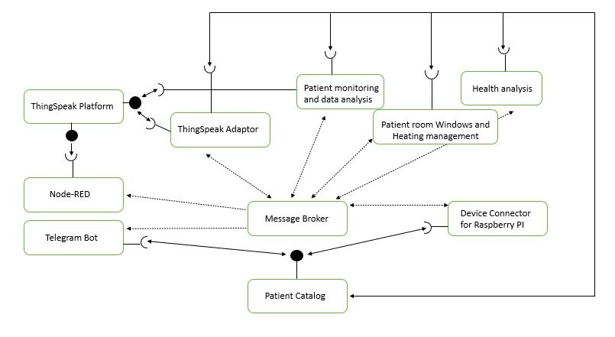
- Complete description of the system
The proposed IoT platform for Patient Monitoring follows the microservices designing pattern. It also exploits two communication paradigms: i) publish/subscribe based on MQTT protocol and ii) request/response based on REST Web Services.
In this context, ten actors have been identified and introduced in the following:
- The Message Broker provides an asynchronous communication based on the publish/subscribe approach. It exploits the MQTT protocol.
- The Patient Catalog works as service and device registry system for all the actors in the system. It provides information about end-points (i.e. REST Web Services and MQTT topics) of all the devices, resources and services in the platform. It also provides configuration settings for applications and control strategies (e.g. list of sensors and actuators). Each actor, during its start-up, must retrieve such information from the Patient Catalog exploiting its REST Web Services.
- The Raspberry Pi Connector is a Device Connector that integrates into the platform raspberry pi boards. Each raspberry is equipped with temperature, heart rate and oxymeter sensors to provide information about the status of health of patient. It provides Rest Web Services to retrieve information. It also works as an MQTT publisher sending information of patient.
- The Thingspeak Adaptor is an MQTT subscriber that receives measurements and upload them on Thingspeak through REST Web Services.
- Thingspeak is a third-party software (https://thingspeak.com/) that provides REST Web Services. It is an open-data platform for the Internet of Things to store, post-process and visualize data (through plots).
- Node-RED is a dashboard to retrieve data from IoT devices and visualize them exploiting the REST Web Services provided by Raspberry Pi. It also exploits the Thinkspeak Web Services to import plots about measurements.
- Telegram Bot is a service to integrate the proposed infrastructure into Telegram platform, which is cloud-based instant messaging infrastructure. It retrieves measurements from IoT devices exploiting the REST Web Services provided by Raspberry Pi. It also allows users on sending actuation commands to IoT devices again exploiting REST.
- Patient monitoring and data analysis: monitoring the patient situation with pre-defined period for each sensor. Analysing data in both short- and long-term period.
- Health analysis: it gives the doctor the possibility to get weekly or monthly trends about vital parameters of the patient.
- Room Windows and Heating management: it is actuated by the Raspberry PI to setup the room temperature and the air quality according to the value of respectively oxygen level and temperature of the patient.
- Desired Hardware components (only among those we can provide)

Device Name | Quantity | Needed for…

